Summer at Our Father’s Table
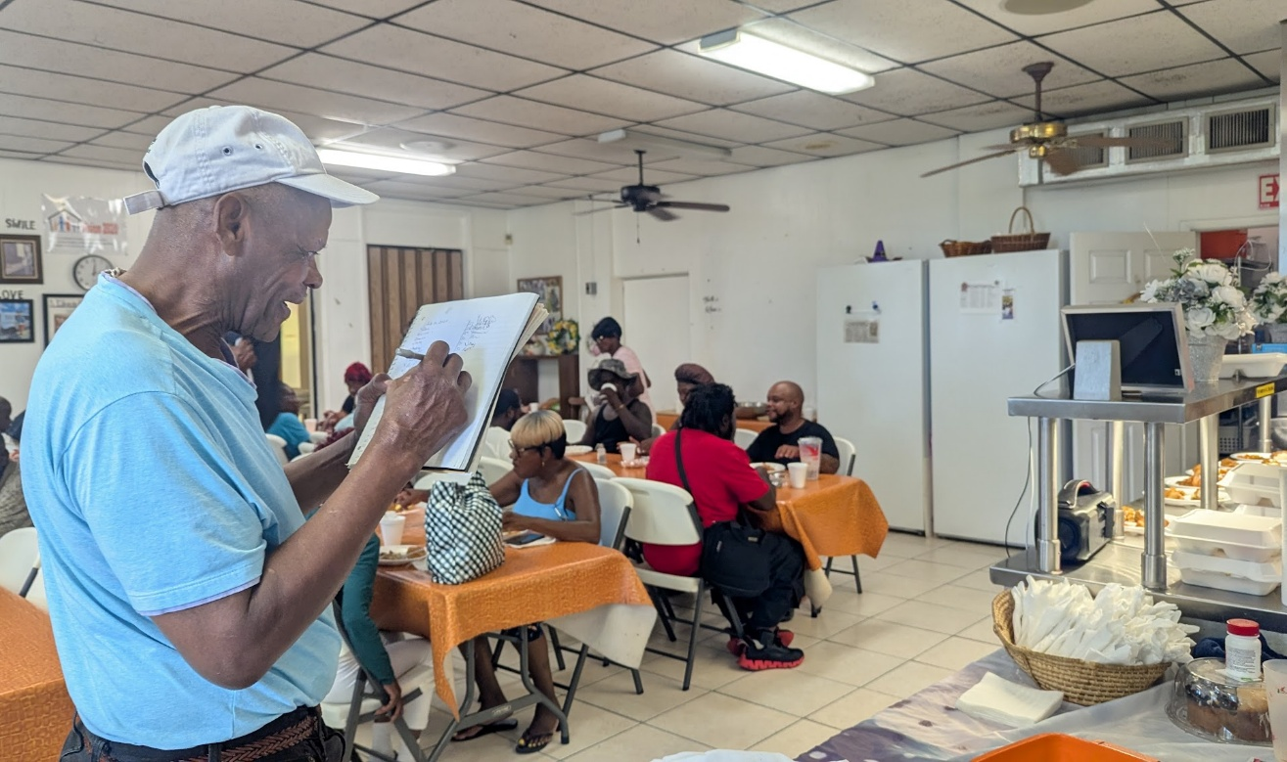

Summer is in full swing, and so is the essential work at Our Father's Table! Our dedicated team continues to provide over 80 meals for delivery Monday through Friday, including a crucial double meal on Fridays to sustain clients through the weekend. Inside our dining room, we're serving 40 to 50 nutritious meals daily, a testament to our clients' resilience despite the summer heat. People like Bobby, an 82-year-old battling glaucoma, faithfully make the journey to Our Father's Table, drawn by the promise of good food and vital companionship.

